**Hardware runs**

**Run 1:**

**Diagram**

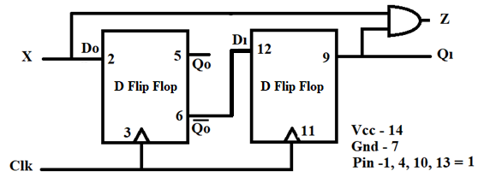

**Q.** Which type of Machine it is?

**Ans.** Mealy Machine

**Q.** Complete the state table by observing the outputs on LED panel.

**State Table**

|  |  |  |  |  |  |
| --- | --- | --- | --- | --- | --- |
| **Present state** | | | **Next state** | | **Output** |
| **Q1(t)** | **Q0(t)** | **X** | **Q1(t+1)** | **Q0(t+1)** | **Z** |
| 0 | 0 | 0 | 1 | 0 | 0 |
| 0 | 0 | 1 | 0 | 1 | 0 |
| 0 | 1 | 0 | 1 | 0 | 0 |
| 0 | 1 | 1 | 0 | 1 | 0 |
| 1 | 0 | 0 | 1 | 0 | 0 |
| 1 | 0 | 1 | 0 | 1 | 0 |
| 1 | 1 | 0 | 1 | 0 | 0 |
| 1 | 1 | 1 | 0 | 1 | 0 |

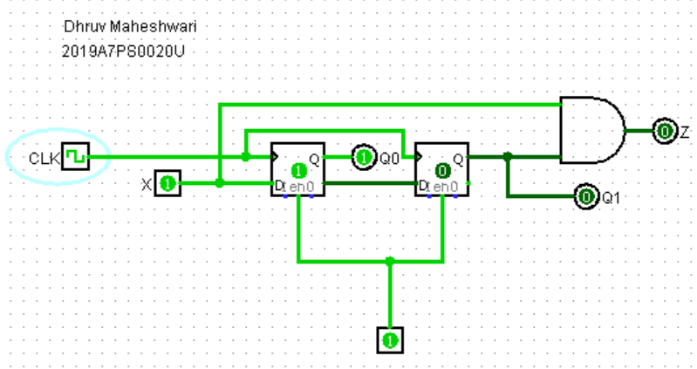

**Q**. Draw the State diagram from above state table?

**Ans.**

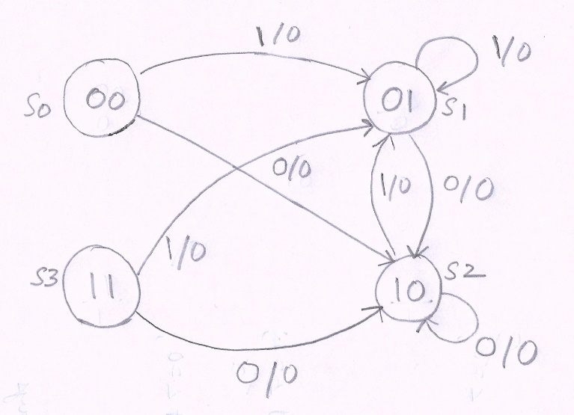

**Software runs**

**Run 2: Mealy Machine: Zero detector after series of 1**

**Q:** Paste the screenshot of waveform window where you get the waveforms for the above code. (online students also paste the URL).

**A:** [**https://www.edaplayground.com/x/K2xB**](https://www.edaplayground.com/x/K2xB)

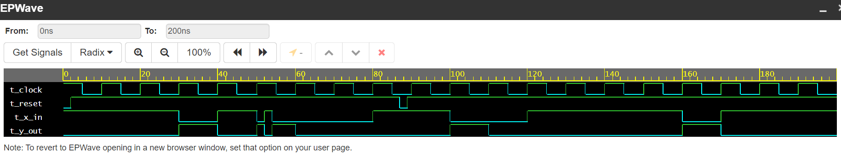

**Q.** Complete the state table below from the waveform observed.

**Ans. State Table-**

|  |  |  |  |
| --- | --- | --- | --- |
| **Present state** | | **Next state** | **Output** |
| **state [1:0]** | **t_x_in** | **next_state [1:0]** | **t_y_out** |
| S0 | 0 | S0 | 0 |
| S0 | 1 | S1 | 0 |
| S1 | 0 | S0 | 1 |
| S1 | 1 | S3 | 0 |
| S2 | 0 | S0 | 1 |
| S2 | 1 | S2 | 0 |
| S3 | 0 | S0 | 1 |
| S3 | 1 | S2 | 0 |

**Run 3: Moore Machine: Zero detector after series of 1**

**Q:** Paste the screenshot of waveform window where you get the waveforms for the above code. (online students also paste the URL)

**A:** [**https://www.edaplayground.com/x/RWHp**](https://www.edaplayground.com/x/RWHp)

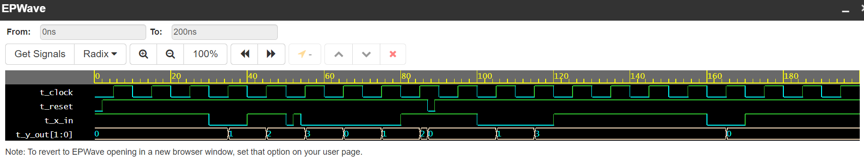

**Q.** Complete the state table below from the waveform observed.

**Ans.**

**State Table**

|  |  |  |  |
| --- | --- | --- | --- |
| **Present state** | | **Next state** | **Output** |
| **state [1:0]** | **t_x_in** | **next_state [1:0]** | **t_y_out** |
| S0 | 0 | S1 | 01 |
| S0 | 1 | S0 | 00 |
| S1 | 0 | S3 | 11 |
| S1 | 1 | S2 | 10 |
| S2 | 0 | S3 | 11 |
| S2 | 1 | S2 | 10 |
| S3 | 0 | S0 | 00 |
| S3 | 1 | S3 | 11 |